Computer Language Coding Concepts

Command Extension
When a base class defines a command, the derived class can add extra functionality to the existing command. The derived class can pre- or post-extend a command from the base class:

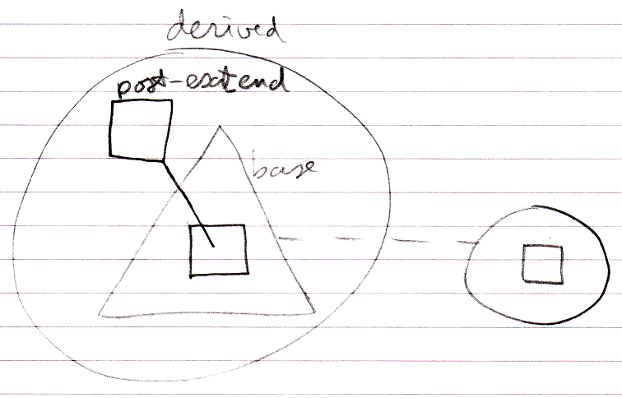

This pre- and post-extension happens by means of the already available system events explained in the Events chapter. The events are actually named Executing and Executed.

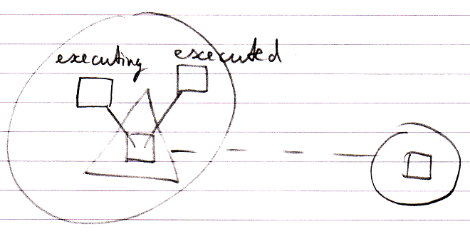

Author & Copyright: Jan-Joost van Zon Date: May 19, 2010 – July 17, 2010 Location: Oosterhout, The Netherlands Status: Finished

